Dear Finance leaders,

As you are aware from the Communication below the PDR process has already commenced and I’m sure you are already underway with your self-assessments and started meeting your teams to discuss 2022 performance.

Here is a reminder of the timeframes of the process. Please note that January 31st is a hard stop and controlled by the group - No extension will be given.

2022 Performance review process

- Evaluation forms are open online from 5th December to 31st January. (current stage)
  - Self-assessment must be completed by all associates.
  - Line managers should meet with each team member to go through the self-assessment and discuss how performance has gone during 2022.
  - A performance rating should NOT be disclosed or confirmed by the line manager in this review meeting.
  - Line managers should complete their evaluation of associates’ performance online. This includes awarding provisional performance ratings in the system, which as mentioned must NOT be disclosed to associates until calibrations are complete.
  - Line managers should follow a recommended rating distribution of 5% Distinguished, 15% Exceptional, 70% Fully performing, and 10% Partially Performing/Not Performing. (bell curve template attached if you wish to monitor your team)
  - During January we will be organizing pre-calibration reviews – the senior management team will meet to review the distribution of final ratings prior to the evaluation forms being locked in. A review session will be booked in the calendar in mid-January before which you should have final ratings prepared to review.

- Formal Calibrations will start on 31st January for business units, clusters and CoEs. Full divisional calibration must be completed and signed off by Auto President by 15th February 2021.
  - All business units, clusters and CoEs must reach the recommended rating distribution of 5% Distinguished, 15% Exceptional, 70% Fully performing, and 10% Partially Performing/Not Performing.

- Communication of final ratings to employees will be on 1st of March. (2nd time to meet your direct reports)
  - Final approved ratings should be communicated face-to-face or on MS Teams by line managers in a formal meeting to officially close out 2022 performance.
  - It will be important at this stage to clearly explain the rationale behind the rating and the performance gap to reach another level must be discussed and development plans agreed. It is important that all line managers take accountability for the rating. If for any reason you are not able to explain the details of the rating, you must request support from your line manager to coach you through it.
  - There will be a small window to hear and decide on any performance rating appeals from 1st to 15th March.

Recommended Deadlines Summary
Associates | Dec 5 – Jan 7
Complete and submit their self -assessment
Managers | Jan 7 – Jan 31
Managers to complete their reviews and recommend Performance ratings *
*It is recommended for all Managers to provide ratings based on the recommended distribution before they input it in the system- You may use the attached bell curve template
Final Rating to be input in the system by 31st Jan
Calibration of Final Ratings | Jan 31- Feb15
Communication of Ratings | March 1

For Off-line employees (AGTL, CMC, TEG)

The offline forms remain the same, Only change the Leadership competency title of Goal obsessed to Goal driven (updated Form attached)

For more learning resources to make the most of the Performance Review please see below in the HR communication for links.

If you wish to read/learn more I urge you to print off/download the attached and take some time to read it. Gallup are a leading performance management consultancy, and it may challenge your thought on Performance Management as well as give you some tips. The green segment below represents a big part of what you will be focusing on during this period (covered within)

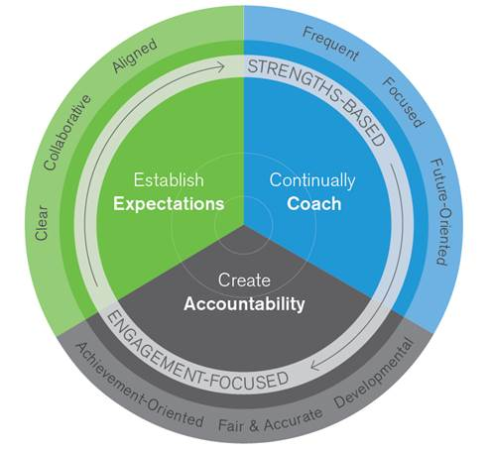

Kind regards,

James Philip

